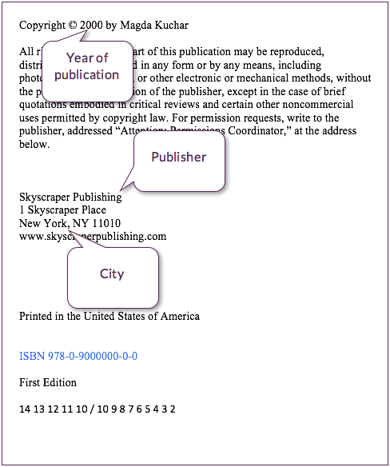../../Downloads/thumbnail_open.png